**Assignment-15**

**Spark SQL**

**The Spark.Sql function():**

**Read a file**

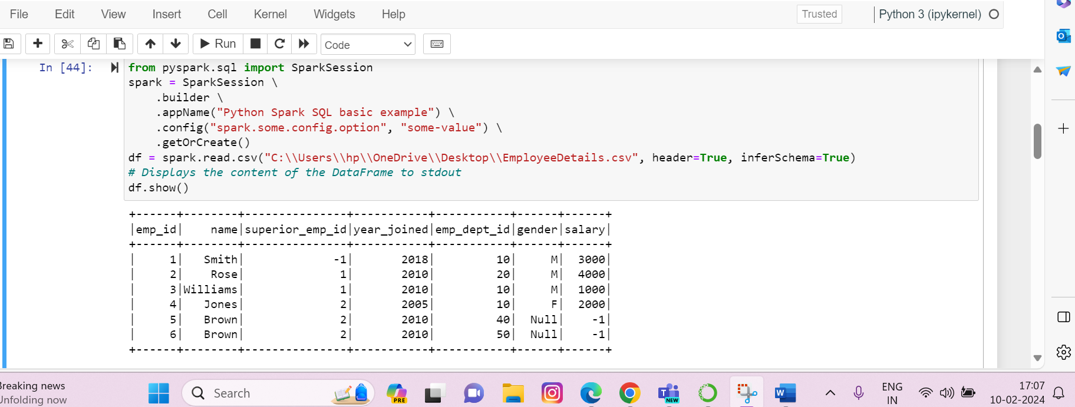

**Printing the Schema:**

**Selecting a particular column only:**

**Selecting two columns and incrementing one columns data only:**

**Using filter():**

**Using groupby() and count():**

**Creatin a temp view:**

**Creating a global view():**

